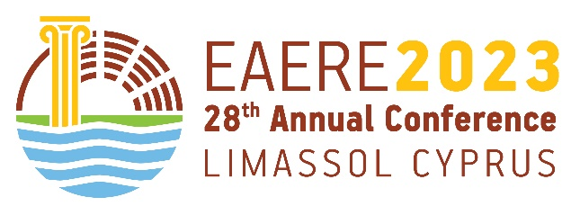 | Limassol, Cyprus  27 – 30 June 2023  28th Annual Conference of the European Association of Environmental and Resource Economists

EXHIBITION APPLICATION
Please submit this form to synedrio@topkinisis.com
DEADLINE FOR APPLICATION: 1st April 2023
DEADLINE FOR PAYMENTS: 26th April 2023

EXHIBITOR INFORMATION
Company name:
Contact person:
E-mail:
Phone:
Correspondence address:
Invoicing address:
Number of persons working at the stand

Promotional Options | FEE (€) | Select
Advanced Stand rental | 1,300
Basic Stand Rental | 1,000
Advert in on-line conference program (1/2 page) | 900
Advert in on-line conference program (1 page) | 1,400
Package offer: one stand rental and 1/2 page advert in conference program | 2,000
Conference social events, without the conference dinner (per person) | These costs will be announced in mid-March 2023, when registrations will open
Conference social events, including the conference dinner (per person)
Conference dinner only (per person)

Note: Estimated number of Conference participants is 700.
Prices do not include VAT; see document “Exhibition Guidelines” on VAT issues.

Signed : …………………………. Date: …………………………

Upon receiving this application form, an invoice will be issued and sent to you by the Conference Secretariat. Please note that the deadline for receiving the payment is May 25, 2023. All bank fees and money transfer costs are the responsibility of the payee.

